Name:___________________________

BCH622 Worksheet: Single-particle cryoEM
structures at 2.2 to 3.7Å

Part 1: β-galactosidase at 2.2Å resolution
[Note: If you're curious about a journal reference, search the code at a wwPDB site.]
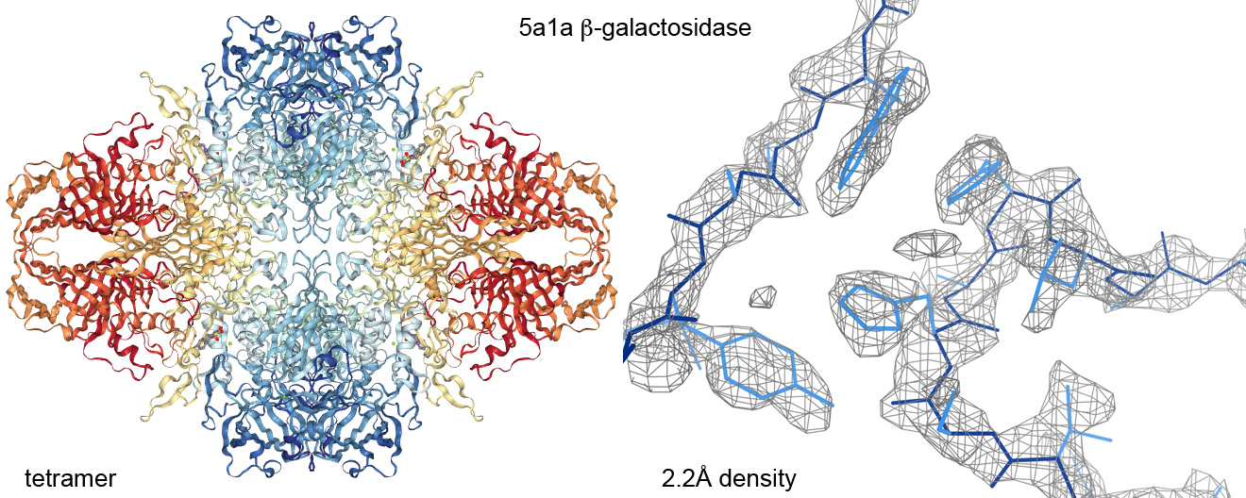
β-galactosidase is a workhorse enzyme for molecular biology -- and a stable, well-behaved homo-tetramer of 1000-residue chains with large contact surfaces (left figure). Even since the "resolution revolution" in cryoEM hardware and software, achieving 2.2Å takes a tractable sample, good luck, and hard work -- but it shows what is possible. There are now a couple of labs that have reportedly gotten to 1.8-1.9Å on model systems
Download and open kinemage 5a1a_beta-galactosidase_2.2A.kin. Map density and model are both very good for the 5a1a structure, as exemplified by the righthand figure. The imaging electrons respond both to electron density and to charge, so positively charged atoms or groups look stronger, as for the 3 Arginines in the kinemage startup view, or presumably also for ___________ . The negatively charged ones look weaker, as seen in an extreme version for the Glu of View 2 (even though it is in well packed beta sheet), or for ______________ .
β-galactosidases have three genuine, conserved examples of the rare, and therefore presumed unfavorable, cis-nonPro conformation. One is in a β-sheet domain, and two are on parallel β strands close to the active site. Strands 2 and 8 of the TIM barrel have functionally important, conserved cis-nonPro peptides (green) near their ends. The Asp-Trp 569 cis-nonPro is just under the active site, while Ser-His 391 helps bind some substrates. Choose View 3 to zoom in on the Trp 569 peptide. Is its map density convincingly good, with no validation outliers? _______ The 5a1a model also has six other cis-nonPro peptides that are not conserved and are very probably wrong: either trans would fit better, they are unjustified by weak, patchy density, and/or they show multiple validation outliers. Choose View4 to see the Asn-Ser 148 case. Why do we think it is wrong? ___________________
To get in the mood for next week's in-class "roll the barrel" model work, download and open kinemage 5a1a_barrel_ribbons.kin. Each β-galactosidase chain has several β-sheet domains, and also a (β/α)8 TIM barrel domain near the middle of each chain that houses the active site (green in the startup view). The TIM barrel is irregular, with several long loops on top, and an entire beta-sheet domain inserted into a loop along one side. Not all strands are shown with ribbon arrows, because the β H-bonding is only sporadic (probably a combination of real distortions and model distortions). Turn ribbon off and mainchain on, and choose View 2 for a barrel closeup. It has been truncated here to help clarity, and is viewed from the ___ - terminal end of the strands. Strand 1 starts at the barrel top, behind the strand-8 cis-nonPro. How many of the outer connections have a helix? _______ Choose View 3 for a central slice through the side view. At about what angle do the front strands lie relative to the back strands? _______

Part 2: The spliceosome at 3.7Å
Refer to the handout picture from class, to see the gymnastics this big RNA-protein complex undergoes during the catalytic cycle that cleaves the exon-intron junctions and re-ligates the exons. We will look at the simplest first step, and near-highest resolution structure (3gan) at 3.7Å. Like the ribosome, the spliceosome is a riboZyme, it's catalysis done by RNA -- but in this case the flexible but robust framework of the complex is provided by proteins, most of which come in and out dynamically.
Download and open kinemage 5gan_spliceosome_tri-snRNP.kin; the startup view matches the top-left image in the cycle picture, but just showing mainchain. Turn off the "protein" button to see the snRNP RNA chains, which converge near the central active site (messenger RNA is not yet bound). Turn the proteins back on.
As usual, the central portion of this big cryoEM structure is the most well-ordered; choose View 2 to see a very long alpha-helix near the center. About how many turns does it have?________ Turn on the "ED 10sig" map and "sidchain" to see a high contour level of the density and move gently back and forth, to see the slightly curly backbone and its sidechain nubbins. Near the center of the long helix, there are two His pointing toward the RNA and 5 charged sidechains pointing up and out. Is essentially the whole sidechain in density at this 10-sigma contour for the His? _______ ; for the charges? _______ At a lower contour level there is more sidechain density, but seldom clear and complete on the outside of the molecule at this overall resolution. Turn to look down the helix axis; are there any contours inside the backbone? _____ (The density is so broad and nearly tubular that the interior of a contour is quite wide.)
Choose View 3 to see the nearby RNA, where the density very clearly is double-helical. Turn to look down the axis; this time the center really is open (except for water and ions, which can't be seen at this resolution). Back in View 3, move around, to see the density for the bases. Is that density more continuous between the bases of a pair, or across the stacking between successive basepairs? __________________________
Return to View 1 and turn off map and sidechains. The most obvious feature of this structure is the 3 big cylinders at the corners, which are the 7-mer snRNP core complexes, in yellow (U4), red (U6), and blue (U5). The 3 are very closely related, and each is a not-quite symmetrical ring of 7 very similar "Sm" proteins, each of which binds one base of the heptamer recognition RNA sequence for that number U snRNP. The Sm fold has an N-terminal helix and a highly bent beta sheet of 4 strands.
[Note: snRNP stands for small nuclear RiboNucleoProtein. You might think Smt means Spliceosomal module -- but no, it means a strong antigen for patients with the Sm serotype of lupus.]
Choose View 4 to see the U4 snRNP core (yellow), with its RNA (lime) bound through the center. To see the ~ 7-fold symmetry better, turn off RNA and switch from mainchain to virtual backbone, where each of the 7 Sm proteins is a different color. Then clip down or choose View5 to see the 7 bases of its recognition sequence (AUUUUUG, sea-green), each in a somewhat different conformation and bound to its Sm chain in a somewhat differently-shaped pocket by mostly conserved sidechains. Switch back to just mainchain and choose View 6. Which side of the ring is appropriately called the "flat" side (left, or right)? ________ and which the "tapered" side? ________
Now choose View 7 to see the U6 snRNP 7-Sm core, in red, with 5 of its recognition nucleotides modeled in its central opening. The interactions between Sm chains are quite tight, most notably that beta-strand 4 is H-bonded to strand 5 of the neighboring chain. Choose View 8 to see one of the resulting 8-strand beta sheets. Is it parallel or antiparallel beta? (If in doubt, turn H-bonds on and off) _________________ Turn on the ED 3sig map. This density, though weak, does strongly suggest strands; is it continuous along the modeled strands? _______ The density is even weaker toward the _______________ edge, which is more exposed.
These wildly dynamic RNP-complex structures can now be solved by single-particle cryoEM but not by crystallography -- one of the places where the "resolution revolution" in cryoEM was truly game-changing. We gain many biologically-important insights from those structures, although in this spliceosome set at 3.5Å or worse the details are not all reliable, especially toward the outside of the particle. Those difficult parts could not be sensibly modeled at all without prior crystal structures of the pieces, but even the pieces
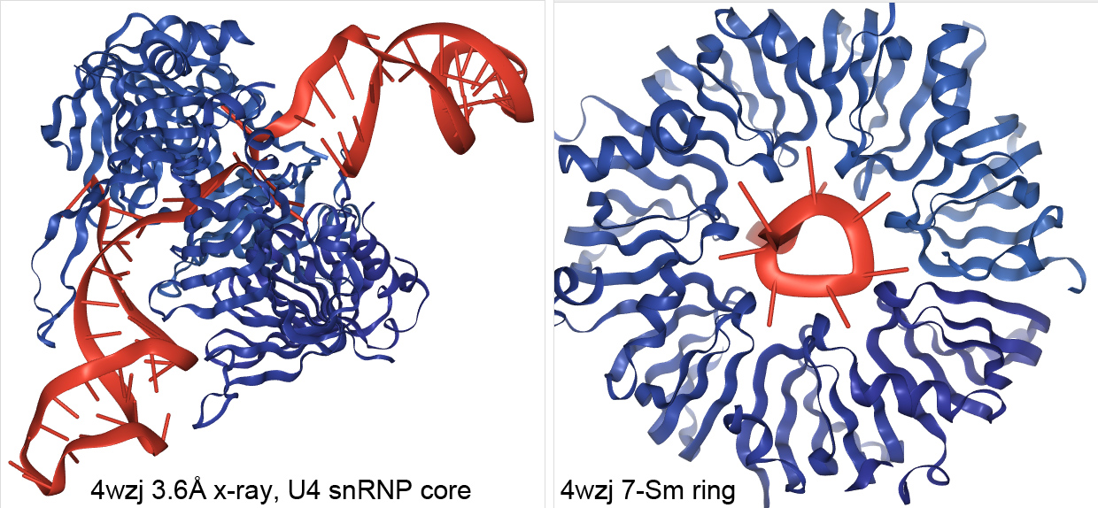
are hard to crystallize. The Nagai group started in 1999 with two crystal structures of Sm-protein dimers (1d3b and 1b34), and after much work their most enabling crystal structure was of the U4 core snRNP, with its 7-Sm and RNA (4v5u). It had 12 whole copies in the asymmetric unit of the crystal and was twinned, so they later rebuilt and re-refined it (4wzj), finding an incorrectly bound recognition base, a sequence misalignment in the SmE chain and other changes, achieving clear density fit and much better R-values. 4wzj was the reference model for building the three snRNPs cores of 5gan that you've been looking at, so even with conformational change and some unclear details, their overall fold and positioning is not in any doubt. Two views of 4wzj are shown in the figures below.

