Name:____________________________
Worksheet: Amino Acid Roles, Mutation, (rev 2019)
and a Diversion
Part 1: structural roles of the amino acids
Refer to the class notes on structural roles of the amino acids.
File c1Basics-A-King.kin contains 5 individual kinemages.
Use Kinemage 1 as a reminder of kinemage operations and stereochemistry of peptides.
Kinemage 2
Kinemage 2 animates disulfide formation in an engineered mutant of T4 phage lysozyme. Click repeatedly on the onscreen button labeled “ANIMATE” (or press the ‘a’ keyboard key) to change between the reduced form, with SH Cys, and the oxidized form, in which the Cys sulfurs are covalently bonded into a disulfide. Sulfur atoms are shown as gold balls, and H atoms (only present in the reduced SH form) in brown. Often there is essentially no backbone movement when a disulfide forms, but in this case two separate domains of the T4 lysozyme structure hinge to come somewhat closer together when the SS bond forms; choose View2 to see this motion. View3 is a closeup of the SS bridge, which is in the righthand hook conformation, one of the two commonest conformations for disulfides; the other common one is the lefthand spiral. For the LH spiral the 3 dihedral angles across the SS are -, -, - while for the RH hook they are +, +, - (the handedness is named after the central dihedral around the S to S bond). To measure that central SS dihedral, choose “Measure angle & dihedral” on the TOOLS menu and click successively on the Cb, Sg, Sg', and Cb' of the SS; the dihedral angle is the last number shown: _________°.

Try it in the opposite order, which should give the same number.
Kinemage 3
Kinemage 3 shows the Calpha backbone of dihydrofolate reductase (DHFR), with each type of side chain on a separate button. View1 shows the central beta sheet from the side. View2 is an edge view, showing the twist of the beta sheet. Click “Animate” to switch among the four groupings of side chains (use View2) and see how they differ in overall location. The strongly hydrophobic residues Cys, Phe, Ile, Leu, Met, Val, Trp (in gold) predominantly pack against each other to form the inside core of the protein, while the permanent charges Asp, Glu, Lys, Arg (+ in skyblue and - in pink) are nearly always on the outside. The neutral and polar groups (in cyan) are more evenly distributed, with a more modest preference for the outside. Pro (green) is also usually outside, even though its side chain has no polar atoms, since it is so good at ending helices and turning corners. Gly (labeled with a “G” at the Calpha) has 3 different sorts of major roles: it occurs a) at corners or at ends of pieces of secondary structure (often with otherwise disallowed conformational angles), b) at especially tight contacts inside a protein, and c) where flexibility of motion is needed. [For DHFR specifically, there is an extremely unusual Gly-Gly cis peptide conserved at the active site.]
Many amino acids have roles at particular positions in specific secondary structures. Gly is by far the commonest amino acid at helix C-termini; to see Gly 86 ending an alpha helix, choose View 3 and turn on “ca + mc” rather than “ca only” (at bottom of button panel). Turn to view from the helix end, to see that at this typical Gly “C-cap” the backbone turns insideout relative to the normal pattern in helix; the peptides on either side of the Gly both make H-bonds to the previous helical turn, but in the opposite order. The N atom of Gly 86 is too far (3.62 Å) to H-bond with the usual n-4 CO; how far is it from the n-3 CO? ______ Å
Ser 77 is the “N-cap” residue at the start of this same alpha helix (turn on the “other” group of sideshains). The N-cap residue is defined as the one whose preceding peptide is out of the helix but whose following peptide is in the helix. Turn the image around, to see that the backbone past the Ser N-cap follows the helical spiral, while the backbone before it goes in a completely different direction; the Calpha of the N-cap residue is where that abrupt change takes place. Ser, Thr, Asn, and Asp are all very common in N-cap positions, usually making an H-bond from the side-chain oxygen to a free backbone NH group in the first turn of the helix, as in this case (H-bond shown in purple). Interestingly, Gln is the least preferred residue in the N-cap position (the extra methylene group in its side chain, vs. Asn, does not allow the side-chain oxygen to get into the correct geometry for the H-bond), which emphasizes that residues whose properties look superficially similar do not always play equivalent roles in protein structure. Gln, on the other hand, is especially common in exposed positions in the middle of helices; to see one in such a place, choose “Find point” on the “Edit” pulldown menu, enter “gln 102”, and search. Zoom smaller and rotate the image, to see that the Gln is indeed exposed. Pro prefers corners in the backbone, many of which are at one end of a piece of secondary structure. To see Pro 25 at the beginning of a helix (at top) and 3 other Pro (bottom) at the ends of beta strands, go to view 4 (turn on the “Gly,Pro” button) . Which position is Pro 25 (Ncap, Ncap+1, etc.)? ___________
Arg and Lys are another pair of similar residues with often-divergent roles. Turn on “charges” and “hydrophobics”, and choose view 5 for a close-up of Arg 158: the aliphatic part of its side chain makes hydrophobic contacts to the Trp 133 ring, while the flat, positively charged guanidinium group at its end reaches over to interact electrostatically with the negative helix dipole at the C-terminus of a helix and also H-bonds to the free backbone CO group of residue _________ ______ . An Arg guanidinium can make as many as 5 planar H-bonds to oxygens and often does so, therefore tending to have a well-defined, tied-down position. Lys, in contrast, makes H-bonds with its very freely rotatable NH3 group, which is often quite mobile in proteins and interacts well with bulk solvent. Of the 7 Lys in DHFR, 2 of them were so mobile that only a few side-chain atoms could be located in the crystallographic structure: use “Edit/Find point” to center on Lys 76, which is only shown out to its Cbeta since the rest was mobile and invisible.
The main function of the large hydrophobic residues is to form hydrophobic cores; the different types pack together in distinctive geometries and have different preferences for backbone conformation. Turn on “hydrophobic” and “other” sidechains and choose view 6 to see 4 aromatic side chains in a vertical row (Y151, F153, & Y111 on the beta sheet and W30 from a helix), some interacting with their rings perpendicular (the more common arrangement) and one pair with stacked rings: _______ _____ with _______ _____. Go to view 7 to see a set of 8 Ile and Val on both sides of the beta sheet. Of the aliphatic side chains, the ones with branched Cbetas (Ile, Val) prefer beta sheet, while Leu and Met prefer alpha helices. Individual residue types can be toggled on one at a time in this kinemage - try that, back in View1 (note that buttons are labeled with both one-letter and 3-letter amino acid codes). If all amino acids were equally represented in DHFR, there would be approximately 159 residues/20 = 8 of each. Amino acids that occur much more often than that in DHFR include Asp (14), Ala (13), and Ile (12). What is the least common hydrophobic amino acid in DHFR (hint: with < 4 examples )? _______ with ___ examples
Kinemage 4
Kinemage 4 has backbone in white, and shows 27 superimposed examples of leucine side chains from 11 protein structures at 0.9 to 1.2 Å resolution (the button for each example gives its 4-character PDB code and residue number). Only a few combinations of side-chain “Chi” dihedral angles occur in these very accurate structures; such clusters of preferred conformations are known as “rotamers”. All of them have one of the three possible staggered values for both Chi1 and Chi2 (near -60°, near 180° or trans, or near +60° degrees). Leu is surprisingly strongly constrained, with over 90% in one of just two rotamers: either mt (Chi1=-60, Chi2=trans; examples shown in gold) or tp (Chi1=trans, Chi2=+60 ; in cyan). To understand better where the constraints might come from, turn off the minor rotamers (in pink), turn on “H”, and move around.
Kinemage 5
Kinemage 5 shows in 3-D the di-iron center in ribonucleotide reductase, which produces a catalytically important free radical on the neighboring tyrosine (upper left). Each Fe has 6 ligands arranged octahedrally, including the bridging oxygen ion, a bridging Glu, waters, and other carboxyl O’s and histidine N’s (marked with color-coded balls). What is the shortest distance for one of the O-Fe bonds? ________ Å To see the local environment of these side chains within the mostly-helical protein subunit, choose View2 and turn on “Calphas”. On one of the 4 surrounding helices, a turn is widened, presumably to allow the ligand sidechain _______ _____ to reach Fe2. (Look down the helix axis to see this.)
Quit out of KiNG

Part 2: An interesting structural motif, with mutational analysis
- Evaluating a “Tyr-corner” to Gln mutation in gamma-crystallin
Read the Hemmingsen et al (1994) Tyr corner paper, optionally skipping the sections between “Position in structure” and “Discussion”. Can you find two bad puns in the paper?
, .
Bring up the file 1gcr_Tyr_corners-2015.kin in KiNG, , go to Menu/Display/ribbon sides… and uncheck “Color by side (alpha)”
Shift the view point enough to appreciate how similar the 2 domains are in ribbon representation, and that adjacent pairs of β strands wind around together to make the Greek key fold.
Turn off 1gcr ribbon, and turn on mainchain, sidechain, H’s, dots, and H-bonds. Choose View 2 to see Tyr 62, one of the classic Tyr corners. The OH donates an H-bond (pale green dots) to the _______ atom of residue _________, which is n minus _____ in sequence from Tyr 62. The critical Gly is residue ______ : locate its Cα. Turn on “Edit/draw/delete” under “Tools”, and select “Draw labels”. Click on the Gly Cα, and edit the label to read just “_G”. Choose “Do nothing” and close the edit dialog. Click in the graphics window and then hit the “w” key on the keyboard to make your G label big. Move around to see the dot pillows for backbone H-bonds to the adjacent β strand; are the Tyr and the Gly Cα’s between narrow or wide pairs of H-bonds? ______________. Back in View 2, turn on “ED map Y62” temporarily, to admire the electron density from the later 4gcr version at 1.47Å.
Now choose view 3 to see the Trp 42 corner; turn on its map, and off again The Trp Ne1 atom H-bonds to the backbone CO of residues n minus _____. Choose Tools/Structural biology/Sidechain mutator, pick 1gcrFH.pdb for the reference coordinates, control-click on a Trp 42 atom and mutate to Gln. Move the Gln dialog box to a convenient position. Turn off the “dots” master button, and ask for “Probe dots” interactive update in the Model manager dialog. Since the original Trp had a minus hi1, try all the Gln rotamers that begin with m. Most clash badly; which rotamer has reasonable contacts and puts the Gln NH2 somewhere near the right place? _____________
Move χ1 to optimize H-bond dots to the backbone CO; at what χ1 value ? ________°
This is very good already, but tweak χ2 a little to balance vdW contacts on both sides of the Gln sidechain; at χ2 _______°. Is there a neighboring donor atom close enough to H-bond with the Gln Oe ? ________
Gln is also much less rigid than Trp, so less effective as a β arch support.
Finish and don’t keep.
Now try mutating to Tyr. Which rotamer is best? __________ Can you make a good sidechain-backbone H-bond without clashes? ________ This illustrates the different requirements of the n-4 and n-3 Tyr corners.
Finish, don’t keep, and quit from KiNG without saving.
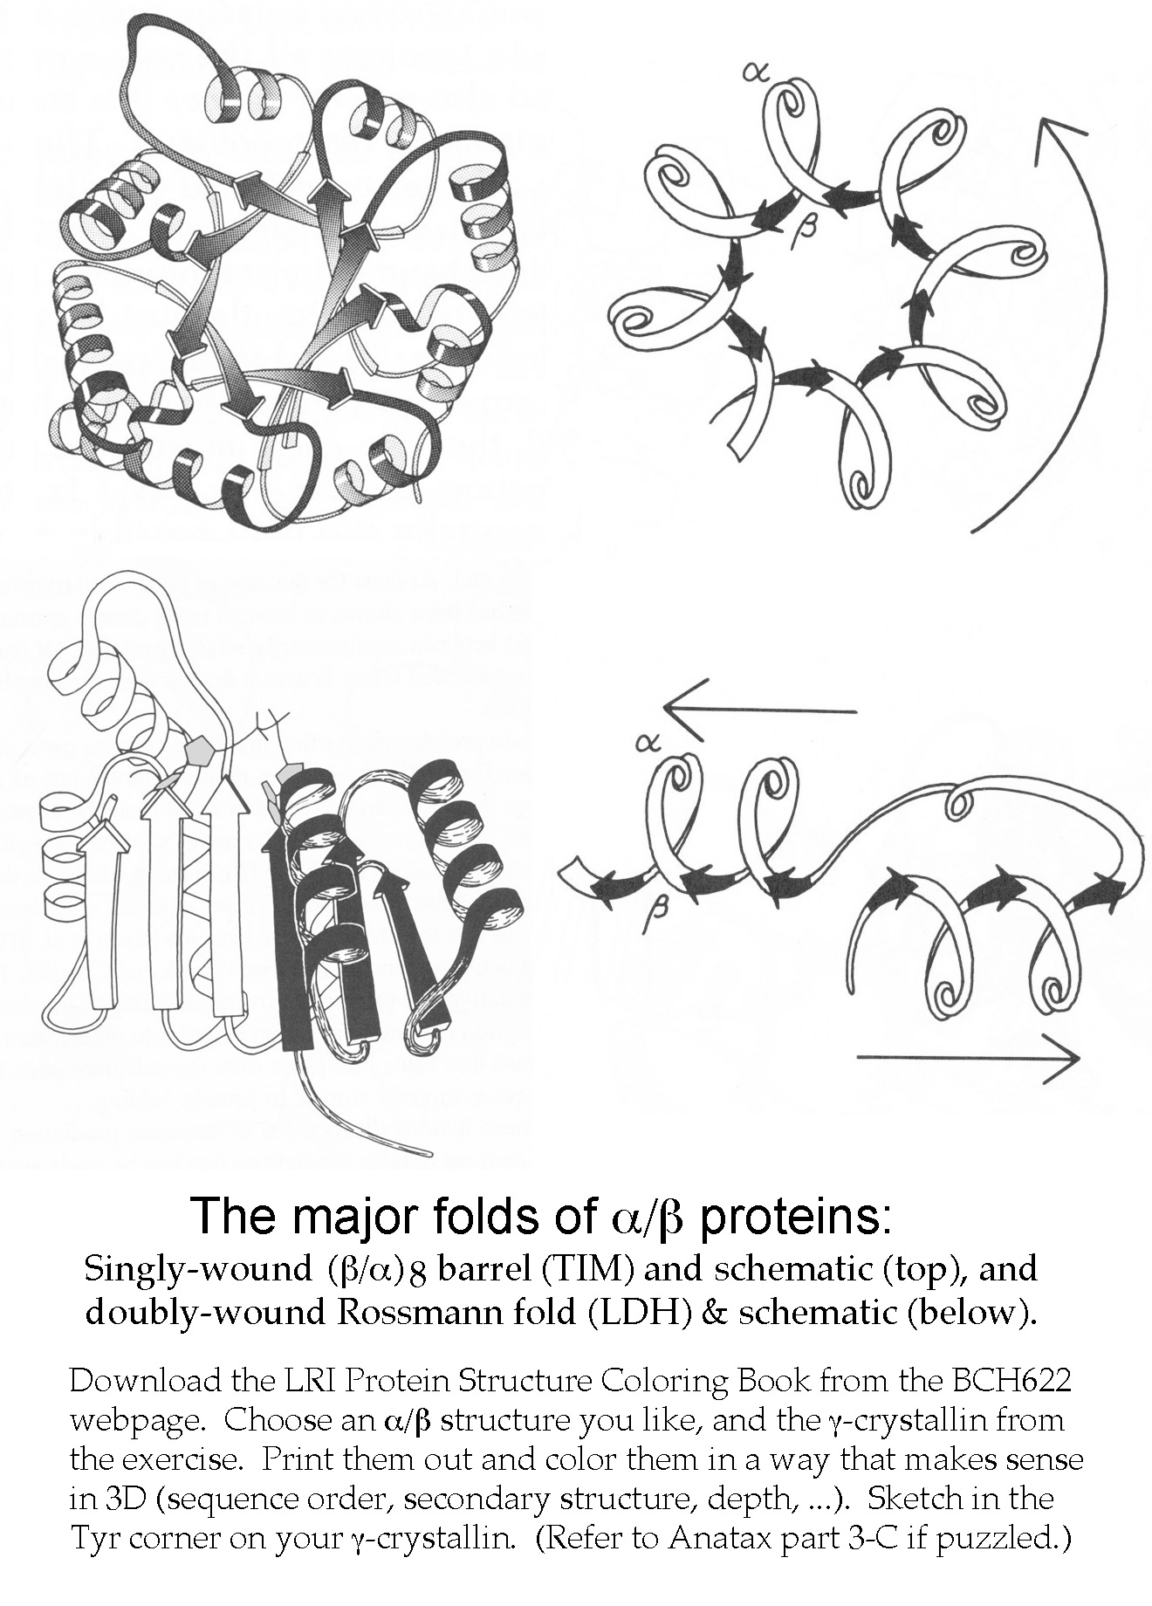
Part 3: A relaxing, educational, & trendy coloring-book exercise

